*//Low Pass Filter Using Hanning Window N=7*  
*//Performed By Sonu Sharma T2b 630*  
clc  
N=1:7  
M=6  
Wc=1  
for N=1:7  
 if(N==4)  
 hd(N)=Wc/%pi  
 else  
 hd(N)=(sin(Wc\*(N-4)))/(%pi\*(N-4))  
end  
end  
for N=1:7  
 W(N)=0.5-(0.5\*(cos(2\*%pi\*(N-1)/M)))  
end  
for N=1:7  
 h(N)=hd(N)\* W(N)  
end  
W1=-1\*%pi:0.1:%pi  
for i=1:length(W1)  
 H(i)=0  
 for N=1:7  
 H(i)=H(i)+h(N)\*(exp(-1\*%i\*W1(i)\*(N-1)))  
end  
end  
disp(hd,'hd(N)')  
disp(W,'W(N)')  
disp(h,'h(N)=')  
hr=abs(H)  
subplot(2,1,1)  
plot(W1,hr)  
xlabel('frequency')  
ylabel('magnitude')  
title('magnitude plot')

*//OUTPUT:*

*//hd(N)*  
*// 0.0149733*  
*// 0.1447192*  
*// 0.2678485*  
*// 0.3183099*  
*// 0.2678485*  
*// 0.1447192*  
*// 0.0149733*  
  
*// W(N)*  
*// 0.*  
*// 0.25*  
*// 0.75*  
*// 1.*  
*// 0.75*  
*// 0.25*  
*// 0.*  
  
*// h(N)=*  
*// 0.*  
*// 0.0361798*  
*// 0.2008864*  
*// 0.3183099*  
*// 0.2008864*  
*// 0.0361798*  
*// 0.*

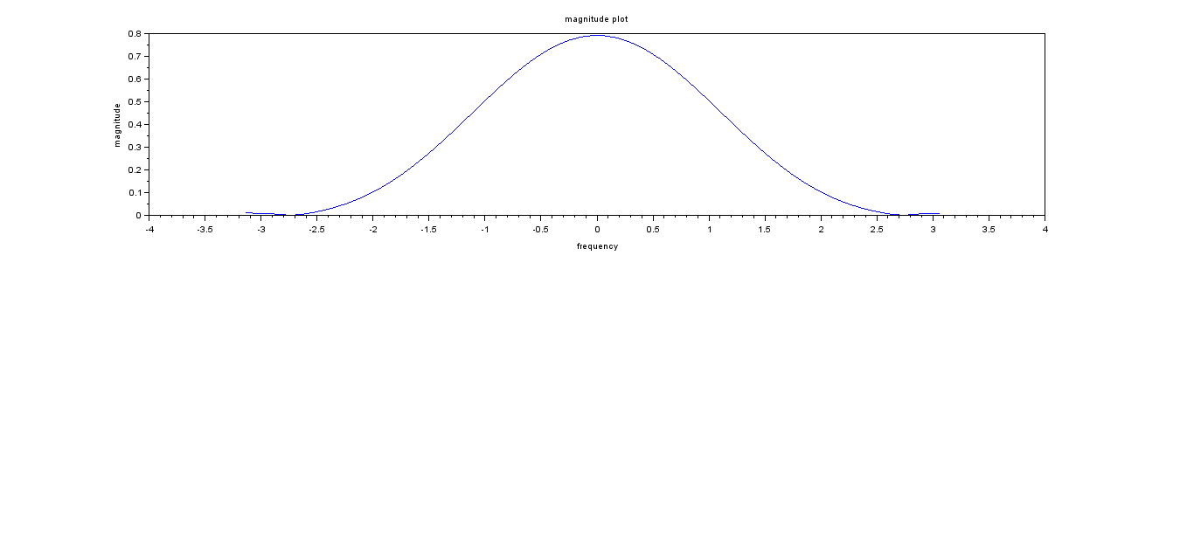

*//High Pass Filter Using Hanning Window N=7*  
*//Performed By Sonu Sharma T2b 630*  
clc  
N=1:7  
M=6  
Wc=0.85\*%pi  
for N=1:7  
 if(N==4)  
 hd(N)=(%pi-Wc)/%pi  
 else  
 hd(N)=(sin(%pi\*(N-4))-sin(Wc\*(N-4)))/(%pi\*(N-4))  
end  
end  
for N=1:7  
 W(N)=0.5-(0.5\*(cos(2\*%pi\*(N-1)/M)))  
end  
for N=1:7  
 h(N)=hd(N)\* W(N)  
end  
W1=-1\*%pi:0.1:%pi  
for i=1:length(W1)  
 H(i)=0  
 for N=1:7  
 H(i)=H(i)+h(N)\*(exp(-1\*%i\*W1(i)\*(N-1)))  
end  
end  
disp(hd,'hd(N)=')  
disp(W,'W(N)=')  
disp(h,'h(N)=')  
hr=abs(H)  
subplot(2,1,1)  
plot(W1,hr)  
xlabel('frequency')  
ylabel('magnitude')  
title('magnitude plot')

*//OUTPUT:*  
*//hd(N)=*  
*// -0.104797*  
*// 0.1287591*  
*// -0.1445097*  
*// 0.15*  
*// -0.1445097*  
*// 0.1287591*  
*// -0.104797*  
  
*// W(N)=*  
*// 0.*  
*// 0.25*  
*// 0.75*  
*// 1.*  
*// 0.75*  
*// 0.25*  
*// 0.*  
  
*// h(N)=*  
*// 0.*  
*// 0.0321898*  
*// -0.1083822*  
*// 0.15*  
*// -0.1083822*  
*// 0.0321898*  
*// 0.*

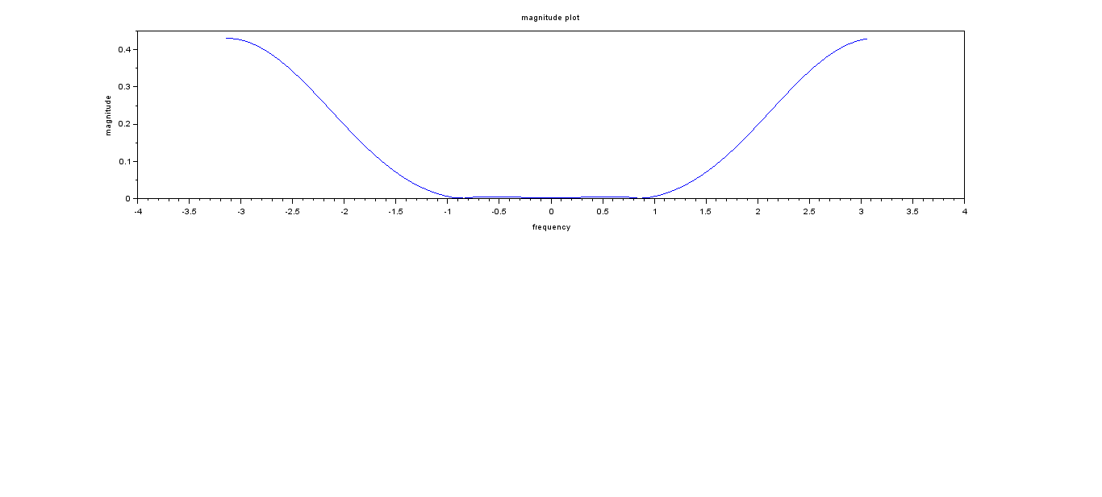

*//Bandpass filter using Hanning window N=7*  
*//Performed by Sonu Sharma T2b 630*  
clc  
N=1:7  
M=6  
wc1=0.4\*%pi  
wc2=0.65\*%pi  
for N=1:7  
 if(N==4)  
 hd(N)=0.25  
 else  
 hd(N)=(sin(wc2\*(N-4))-sin(wc1\*(N-4)))/(%pi\*(N-4))  
 end  
end  
for N=1:7  
 w(N)=0.5-(0.5\*(cos(2\*%pi\*(N-1)/M)))  
end  
for N=1:7  
 h(N)=hd(N)\*w(N)  
end  
w1=-1\*%pi:0.1:%pi  
for i=1:length(w1)  
H(i)=0;  
 for N=1:7  
 H(i)=H(i)+h(N)\*(exp(-1\*%i\*w1(i)\*(N-1)))  
 end  
end  
disp(hd,'hd(N)=')  
disp(w,'w(N)=')  
disp(h,'h(N)=')  
hr=abs(H);  
subplot(2,1,1)  
plot(w1,hr)  
xlabel('Frequency')  
ylabel('Magnitude')  
title('Magnitude Plot')

*//OUTPUT:*  
*//hd(N)=*  
*// 0.0457677*  
*// -0.222308*  
*// -0.0191145*  
*// 0.25*

*// -0.0191145*  
*// -0.222308*  
*// 0.0457677*  
*// w(N)=*  
*// 0.*  
*// 0.25*  
*// 0.75*  
*// 1.*  
*// 0.75*  
*// 0.25*  
*// 0.*  
*// h(N)=*  
*// 0.*  
*// -0.055577*  
*// -0.0143359*  
*// 0.25*  
*// -0.0143359*  
*// -0.055577*  
*// 0.*

*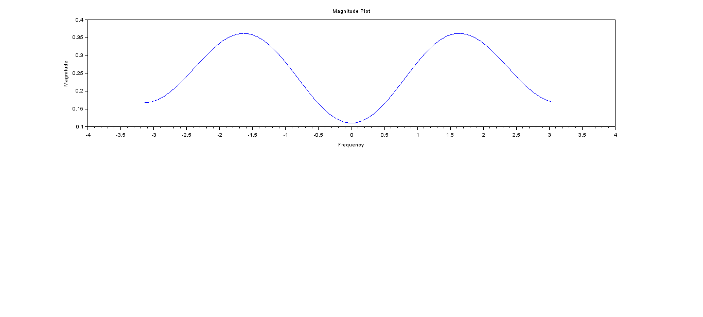*

*//FIR Band Reject Filter Using Rectangular Window N=7*  
*//Performed By Sonu Sharma Roll.no. 630*  
clc  
N=1:7  
M=4  
wc1=0.4\*%pi  
wc2=0.65\*%pi  
for N=1:7  
if(N==4)  
 hd(N)=(wc2-wc1+%pi)/(%pi)  
else  
 hd(N)=(sin(wc1\*(N-4))-sin(wc2\*(N-4))+sin(%pi\*(N-4)))/(%pi\*(N-4))  
end  
end  
for N=1:7  
 w(N)=1  
end  
for N=1:7  
 h(N)=hd(N)\*w(N)  
end  
  
w1=-1\*%pi:0.1:%pi  
for i=1:length(w1)  
 H(i)=0  
 for N=1:7  
 H(i)=H(i)+h(N)\*(exp(-1\*%i\*w1(i)\*(N-1)))  
end  
end  
disp(hd,'hd(N):')  
disp(w,'w(N):')  
disp(h,'h(N):')  
  
hr=abs(H)  
subplot(2,1,1)  
plot(w1,hr)  
xlabel('Frequency')  
ylabel('Magnitude')  
title('Magnitude Plot')

*//OUTPUT:*  
  
*// hd(N):*  
*// -0.0457677*  
*// 0.222308*  
*// 0.0191145*  
*// 1.25*  
*// 0.0191145*  
*// 0.222308*  
*// -0.0457677*  
  
*// w(N):*  
*// 1.*  
*// 1.*  
*// 1.*  
*// 1.*  
*// 1.*  
*// 1.*  
*// 1.*  
  
*// h(N):*  
*// -0.0457677*  
*// 0.222308*  
*// 0.0191145*  
*// 1.25*  
*// 0.0191145*  
*// 0.222308*  
*// -0.0457677*

*